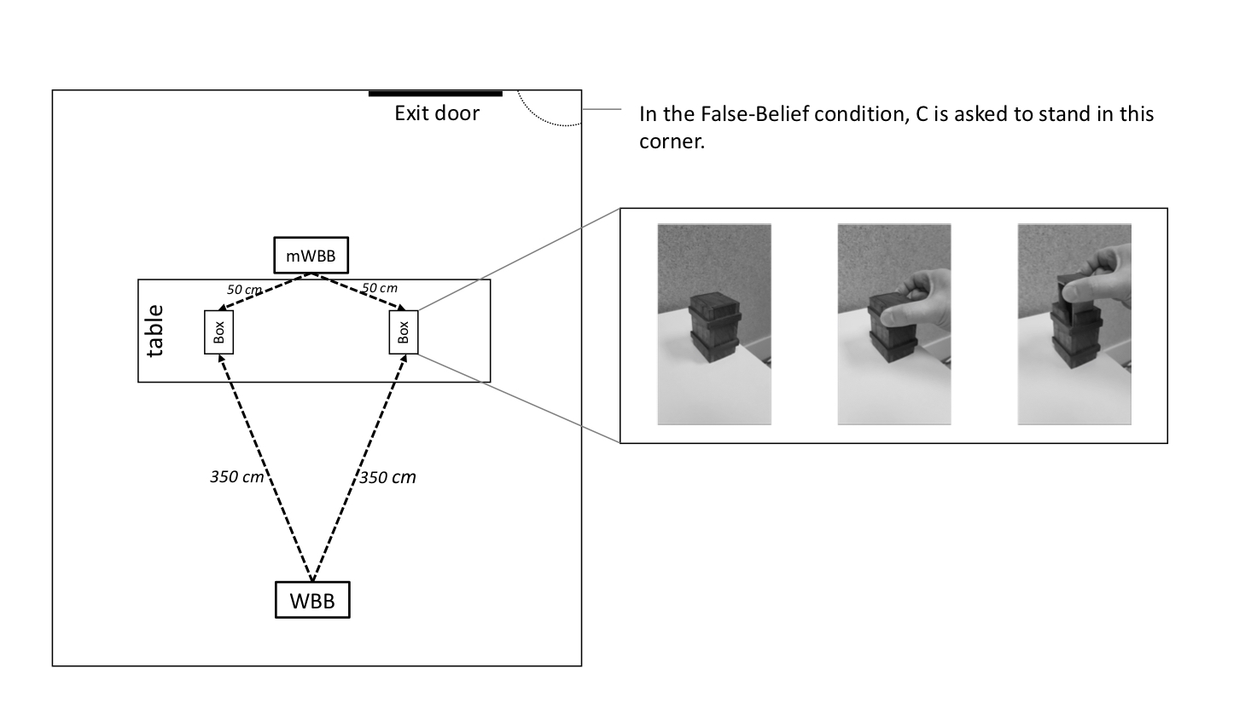

**Figure 1.** Schematic representation of the experimental setting and the boxes’ unlocking mechanism.

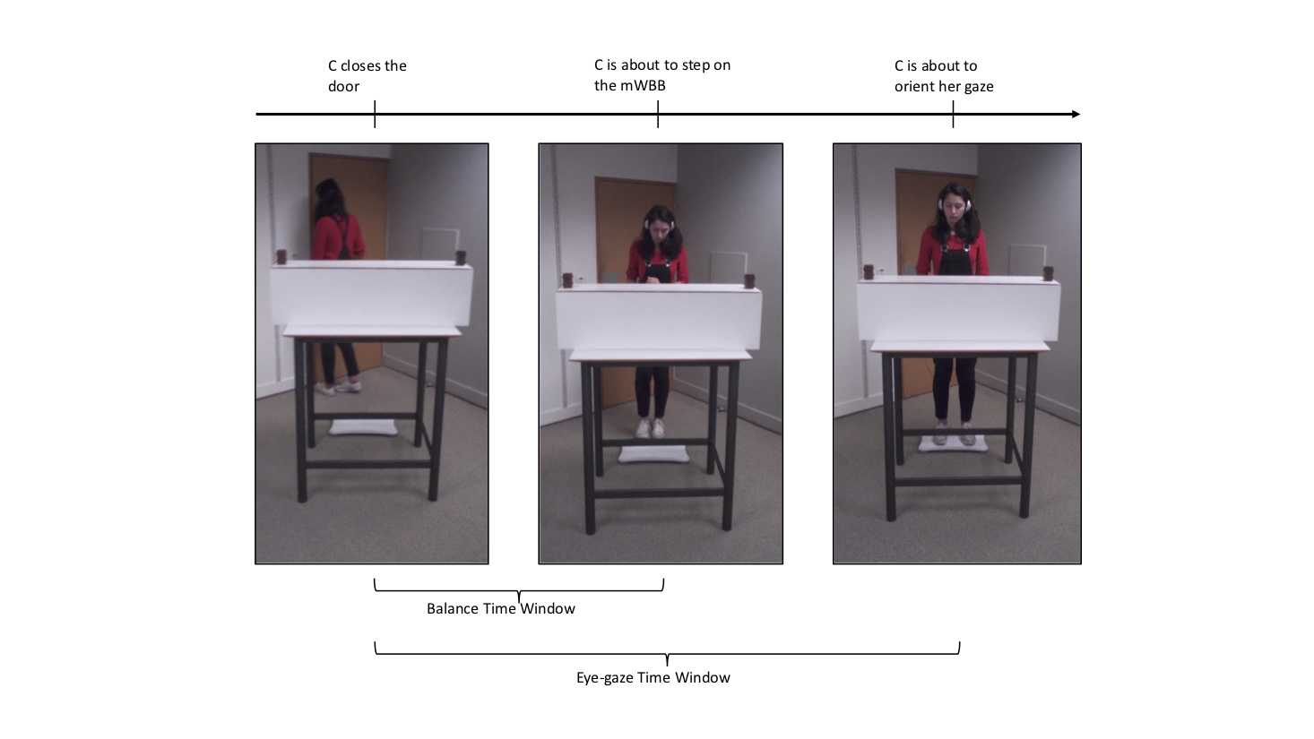

**Figure 2.** Schematic representation of the selected time windows.

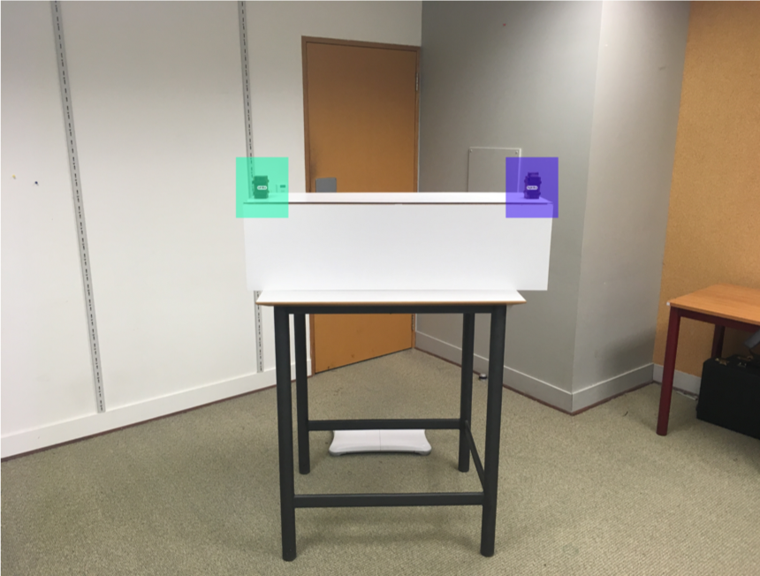

**Figure 3.** Two same-size areas of interest (277 x 317 pixels) were selected for eye-gaze data analysis.

**Figure 4.** Fixation duration (in %) on each box (now-full, now-empty) in false and true belief conditions.

**Figure 5.** Number of participants displaying a first fixation either to the now-empty box or now-full box during the critical time window (N = 24) by condition (false belief or true belief).

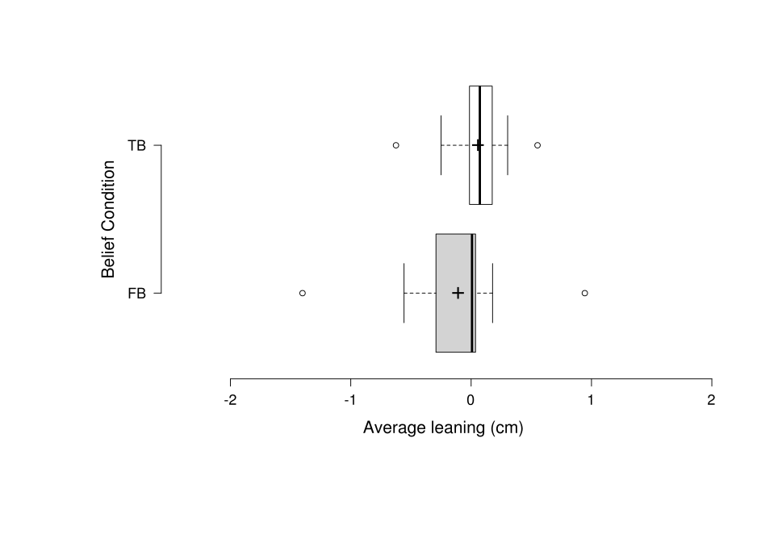

**Figure 6.** Average leaning displacement from body midline (0) by condition [FB = false belief, 17 sample points; TB = true belief, 18 sample points). Positive values reflect a leaning towards the box with the object in it (now-full box); negative values reflect a leaning towards the box in which the object was initially located (now-empty box). Centre lines show the medians; crosses represent means; box limits indicate the 25th and 75th percentiles as determined by R software; whiskers extend 1.5 times the interquartile range from the 25th and 75th percentiles, outliers are represented by dots.

**Figure 7.** Number of participants who helped with either the now-empty or the now-full box (N = 42) by condition (false belief or true belief)

**Table 1.** Numbers of participants in the TB and FB conditions (n = 23 and n = 18, respectively) who provided fact-based, ability-based, or mental-state-based reasons for the questions that sought explanations of why they went to open one box and did not go to open the alternative box. Note that one participant in the TB condition did not answer these questions, and hence the coding of reasons in TB condition was based on data from 23 participants.

|  |  |  |  |  |  |  |
| --- | --- | --- | --- | --- | --- | --- |
|  | **Question 1: Explain why you went to that box.** | | | | | |
|  | Those Who Opened Now-Empty Box | | | Those Who Opened Now-Full Box | | |
| Reason | Fact | Ability | Mental State | Fact | Ability | Mental State |
| TB | 8 | 11 | 1 | 0 | 0 | 3 |
| FB | 2 | 11 | 2 | 1 | 0 | 2 |
|  | **Question 2: Explain why you didn’t go to the alternative box.** | | | | | |
|  | Those Who Opened Now-Empty Box | | | Those Who Opened Now-Full Box | | |
| Reason | Fact | Ability | Mental State | Fact | Ability | Mental State |
| TB | 10 | 5 | 5 | 1 | 0 | 2 |
| FB | 4 | 4 | 7 | 2 | 0 | 1 |